ASK YOUR CLIENTS:  Is Your Medical Practices’ Communication Compliant?  OnPage’s HIPAA-compliant messaging application provides Secure encrypted communications, assurance that information is stored in facilities that are SAS 70 certified  Can Patients Directly communicate with physicians?  Patients can seamlessly call in and leave a voicemail plus a call back number. The voice mail gets attached to a HIGH-PRIORITY message that is automatically routed to the doctor’s OnPage inbox with a prominent Alert-until-Read!  Do you have Crisis Communications Tool?  OnPage Blast IT is designed to help medical organizations streamline effective communications with medical personnel, patients, patients’ families and support staff in times of crisis. | CONTACT US TODAY  OnPage Channel Account Managers  Waltham MA  partners@OnPagecorp.com  1-781-916-0040 |  | PARTNERSHIP  PROGRAM

WHO IS ONPAGE?  OnPage is the industry leading HIPAA secure Incident Alert Management System. OnPage’s unique ALERT-UNTIL-READ notifications for up to 8 hours enables organizations to get the most out of their digital investments, ensuring users have a reliable means to escalate anomaly notifications to the right person immediately.  OnPage’s escalation policies, redundancies, and scheduling algorithms ensure that a critical message is never missed. Infinitely more reliable and secure than emails, text messages and phone calls combined, OnPage reduces incident resolution time by automating the notification process thereby reducing human errors and advancing the digital operations of your business.  Whether to minimize IT infrastructure downtime, or to minimize response time of healthcare providers in life and death situations, organizations are relying on OnPage for all their secure, HIPAA compliant, critical notifications needs. | Give your clients in the healthcare industry the best Clinical Communications through HIPAA compliant messaging and on-call alert automation with Real-Time Call Routing.  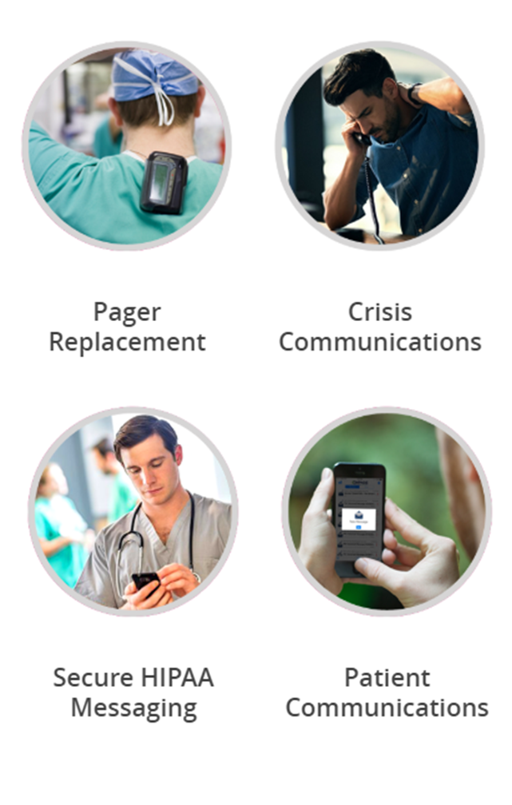 | TOP FIVE BENEFITS USING ONPAGE  Alert until Read  Eliminate alert fatigue by prioritizing urgent notifications. Send High or Low priority alerts, based on your needs. Persistent alerts and repeated delivery ensure incidents get to the right person at the right time. Every time!  Secure and HIPPA Compliant  HIPAA complaint critical messaging service enables users a secure two-way communication. SSL encrypted messages can only be viewed by participants. OnPage content can be remotely wipe to ensure HIPAA  Escalation Polices  Escalation policy ensures that an incident is acknowledged within a pre-determined amount of time, or it will be escalated to the next users. Customizable escalation criteria to warrant flexibility!  Scheduling Algorithms  Create multiple schedules, without limitation to location, so every group gets their preferred on-call rotation. Get instant visibility on whose on-call. Make changes to the scheduler when assignments, objectives, or the weather changes.  World-class customer support  Our dedicated, support team is available 24x7 at no additional cost. The OnPage support team can help design, test, and execute your incident management solution.

